Modeling the Thermocline

Summary  Subject(s)  ESS: Earth’s Systems & Processes  Grade/Level  Grades 6-8  Activity Type  Developing & using models  MN Science Standard  6E.3.1.1.3  SEP / CCC  SEP: Developing & Using Models  CCC: Energy & Matter  Est. Lesson Time  45 Minutes  *This curriculum is the property of the Friends of the Minnesota Valley River Watch program. No part of this curriculum may be reproduced without the written permission of Friends of the Minnesota Valley. | Implementation  Introduction  Water in lakes is not the same temperature from the surface to the lake bottom. Warm water floats to the surface, while cold water sinks to the bottom.  This is because the density of water changes depending on its temperature. Cold water is more dense than warm water, until the water reaches 4° C (degrees Celsius), at which point it becomes less dense the colder it gets. In lakes (typically deeper than 20 feet- about 6 meters), the separation of water densities creates lake stratification, or layers of water with noticeably different temperatures. The point where the temperatures have the greatest difference is known as the thermocline. These layers form in the summer and winter months.  In the summer, the warmer water on the top is heated by the daily sun, and mixes with oxygen stirred in by the movement of the wind, waves, and atmospheric pressure. The deeper water receives less heat from the sun, and settles below the warm layer of surface water.  In the winter, the surface water is frozen into a sheet of ice. Ice is less dense than water, which is why it does not sink. The water just below the ice is colder than 4° C , meaning it floats on top of a layer of warmer water. The lowest layer of a winter lake consists of water that is uniformly 4° C . The sheet of ice stops the surface waters from mixing with oxygen in the atmosphere, meaning there is a limited supply of oxygen in the lake during the winter months.  During the transition seasons, the water heats in the spring sun or cools in the fall weather until all the water in the lake becomes the same temperature and therefore density. At this point, it takes very little wind and wave energy to mix the layers of the lake, in a process called Lake Turnover. Lake turnover is important because it moves the oxygenated water and nutrients from the surface down to the bottom of the lake, where fish and plants use it to breathe. Without this lake turnover, oxygen would not make its way into the bottom of the lake and organisms living there would die due to lack of oxygen.  Key Terms  - Water Column: A visualization of a vertical column of water from the surface of the water to the bottom sediment.  - Water Density: The measure of how tightly packed the water molecules are together. Higher density equals packed tighter. Water has a higher density the colder it is (with some exception). Lower density equals packed loosely. Water has a lower density the warmer it is.  - Lake Stratification: The separation of lake water into different layers based on the water’s density. Low density (warm) water typically rises to the top. High density (cold) water typically sinks to the bottom.  - Thermocline: The part of the water column where high and low density water mixes causing drastic temperature changes in this layer.  - Lake Turnover: The seasonal mixing of the water column as the temperatures of the water layers heat or cool to the same temperature throughout the water column. This process allows oxygen and nutrients from the surface to mix with the water at the bottom of the lake.  Objective  Develop a model to describe the cycling of water through Earth's systems driven by energy from the sun and the force of gravity.  Essential Questions  - What is the water column?  - What factors cause lake stratification?  - What is the main cause of lake turnover?  - Why is it important for lakes to turnover?  - How do you know when the lake is turning over?  - How might lake turnover affect algae bloom? How might an algae bloom affect the lake turnover?  Materials & Resources  - 2 Clear Watertight Containers/Pitchers between 0.5 - 1L  - 1 Large Clear Container between 1.5 - 2 L  - Red & Blue Food Coloring  - Stick Thermometer  - Electric Kettle - to heat water  - Ice - to cool water  - Colored Pencils/Crayons  - Thermocline Scenario Sheet  Procedure  Before the Activity  - Set out the large empty clear container in a place where the whole group will be able to see it.  - Fill one clear container with ice & cold water between a temperature of 3 to 5°C and BLUE food coloring.  - Heat water to at least 80 °C and prepare to fill one clear container with hot water and RED food coloring. CAUTION: handle hot water carefully.  Activity Steps  - Hypothesize what will happen to the water when the hot and cold water are mixed.  - Fill the container with hot water and RED dye, and ensure the dye mixes in. Ensure the cold water and BLUE dye have mixed. Pour the hot water into the mixing container.  - Slowly pour the cold water into the mixing container by running the water along the wall of the container.  - The hot and cold water should mix forming 3 distinct layers (red, purple, blue)  - Find the temperature of the red, purple, and blue layers of water.  Small Group Discussion (10 Minutes): Pair off with another student and discuss the following questions:  - Did the demonstration validate or disprove your hypothesis?  - Where in the water column did the cold water end up? Why do you think that is?  - Where in the water column did the hot water end up? Why do you think that is?  - What do you think is happening in the purple layer in the middle of the water column?  - What do you think would happen if we poured the hot water into the cold water instead?  Large Group Discussion (15 Minutes): As a whole class, discuss the following questions/topics:  - How does this demonstration model lake stratification?  - How might other natural forces (wind, sun) affect the lake stratification? Could we model these forces?  - Which season do you think this demonstration most directly imitates? Why?  - What do you think we would see if we let the water sit for an hour? What season(s) do you think those observations would imitate? Why?  - What can we infer about how each season affects temperatures of the water column?  Wrap-up (5 Minutes): The Key Ideas from the lesson are:  - Water with different temperatures (and densities) will form distinct layers of warm and cold water in the water column, known as [lake] stratification.  - As surface waters change temperature/density during the spring and fall, the lake water becomes the same density throughout the water column, allowing it to turnover.  - Lake turnover involves the mixing of surface and lake bottom waters, and it helps distribute oxygen from the surface to the low oxygen lake bottom waters.
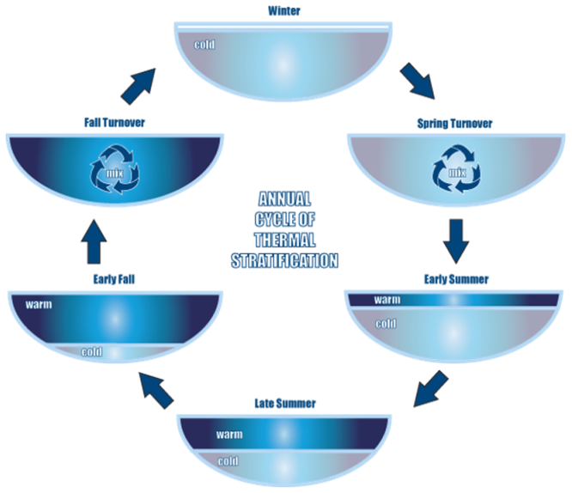

Spring
Fall

Summer (with a South Wind)
Winter

